**GIT Remoting**

**Objective:** Pushing source code into GITHUB & collaborate team members.

SECTION-1 (Pushing assignments to remote repository) - Steps to follow:

39. Create a GitHub account if you do not have already.

40. Login on into github account.

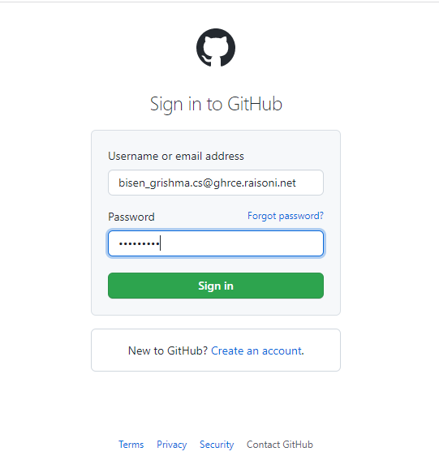

41. Create new public repository ‘freshersbatch-oct16’.

Click on New Repository

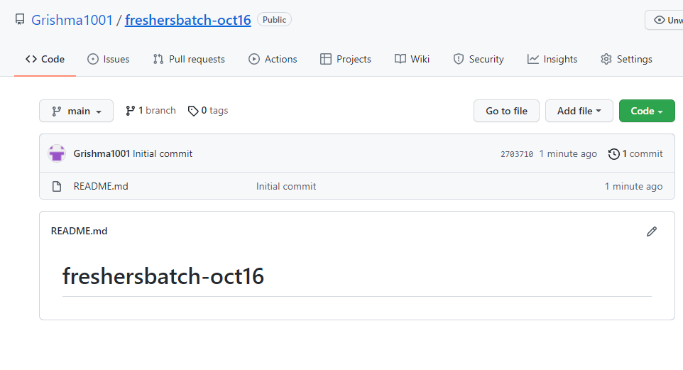

42. Commit & push any sample file to this repository under ‘Assignments’ directory.

Command for pushing to main directory in github using http:

git remote add origin https://github.com/Grishma1001/freshersbatch-oct16.git

git branch -M main

git push -u origin main

